Illinois Youth Survey
2020 to 2022 Revisions Summary

The IYS strives to keep pace with trends in substance use behaviors, attitudes and perceptions, and other indicators measured by the survey. Each administration year, new questions are added and others are removed while maintaining survey length and grade level appropriateness.

NEW Questions Added to the 2022 IYS survey:
Reflecting demographic trends:
- Added question about sexual identity.
- Added question about homelessness.

Reflecting marijuana legalization:
- Added question about purchase from a marijuana dispensary.

Reflecting trends in sources:
- Added question about purchase of alcohol via curbside/home delivery.

Questions Changed / Removed from 2020 IYS:
Questions phrased with ‘when, if ever, did you first’ in 2020 were replaced for 2022 by questions phrased with ‘how old were you when you first’:
- used marijuana
- smoked a cigarette, even just a puff
- had more than a sip or two of beer, wine, or hard liquor (e.g., vodka, whiskey, or gin)
- used an e-cigarette or other vaping product

An additional ‘how old were you when you first’ question was added to this series:

- began drinking alcohol regularly, that is, at least once or twice a month

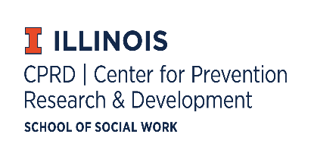
510 Devonshire Drive, Champaign, IL 61820-7306
Local: 217.333.3231 Toll-Free: 888.333.5612
Email: cprd-iys@mx.uillinois.edu
Website: http://iys.cprd.illinois.edu

Funded in whole or in part by the Illinois Department of Human Services, Division of Substance Use Prevention
and Recovery through a grant from the Substance Abuse and Mental Health Services Administration.

